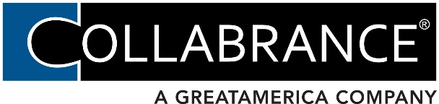
Collabrance, LLC
625 First Street SE, Ste 300
Cedar Rapids, IA 52401
Telephone: 877.715.8485
Email: info@collabrance.com

Solution Provider Information Request

Company Legal Name: DBA:

Start Year: State of Legal Formation: Phone No. (No 800 #):

Web Site: Email:

Physical Address: City: State: Zip:

Contact Name: Title:

Principal Name: SSN:
(only required if under 3 years in business or fewer than 5 employees)
Principal Home Address:

OPERATIONS INFORMATION

Last Fiscal Year Top Line Revenue $ Projected Current Fiscal Year Revenue $

Revenue Split % (approximate): Managed Services % Hardware/Software % Project Work % Break/Fix % Other %

If you sell telephony, what percentage of your total revenue is telephony? %

Total Clients: # of Fully Managed Clients:

What is your Service Leadership Operational Maturity Level (if known):

Internal Software Applications: CRM: PSA: RMM:
Quoting Tool: Accounting: Other:

Vertical Focus: Yes or No If yes, which verticals:

# of Full-Time Employees: # of Sales Reps: # of Techs:

Do you outsource any portion of your MS or Help Desk? Yes or No If yes, with who?

What part is outsourced?

PRODUCT LINE INFORMATION

Technology Stack (Major Manufacturer Lines Sold):

Means of Sales (Check all that apply.): Direct Sales Retail Wholesale Internet Resellers

Manufacturer Authorizations:
- Major Manufacturer Authorization Numbers:
- Manufacturers you buy direct through:
- Distributors/Wholesalers you buy through:

Peer Groups & Industry Events

Peer Groups/Industry Associations:

Industry Events you attend:

*Form must be completed in its entirety

Authorization

I hereby authorize Collabrance LLC, or any agent of Collabrance LLC, to investigate the references listed above and statements or other data obtained from me or from any other person or agency pertaining to my personal credit and financial responsibility.

Date Signature/Title

